Date: February 25th, 2025

To: Sales, Marketing, and/or Products Team

From: Kenton Fong, Senior Financial Analyst  
  
Re: Financial Analysis- Key Insights and Recommendations  
  
Project: New Saas (Software-as-a-Service) Tech Solutions Inc.

**_______________________________________________________**

**Business Profile and Financial Highlights for the year 2024:**

New Saas Technology Solutions (NSTS) is a cloud-based software subscription company that serves 155 major corporate customers globally. The top five customers in 2024 were: Prudential Services, Johnson & Johnson, Bank of America, Ford Motor Co., and Wal-Mart. NSTS ended the year 2024 with a record $72.9 million in net subscription revenue, a 46% increase over the previous year.

**_______________________________________________________**

**Key Insights:**

NSTS provides seven major product solutions and two subscription tier levels (Standard and Premium). The major product offerings are: Artificial Intelligence platform, Business Intelligence software, Core Platform Suite, Customer Service Cloud, Marketing Cloud, Sales Cloud, and Teams Productivity. NSTS offers three different customer support plans: Standard (level 1), Premier (level 2), and Signature (level 3).

In 2024, the Core Platform Suite generated the largest source of net subscription revenue at $15.6 million (or 21% of total company revenue). Business Intelligence software came in second place with $14.9 million (or 20%) of total company revenue.

Below chart contains key statistics for 2024. An anomaly appears in the 3rd and 4th quarter whereby the net MRR (Monthly Recurring Revenues) had temporary decreases. These net decreases are expected to disappear in 2025 as part of more expansions (Cross-Sells and Upsells).



Customer churn rate for 2024 was 0.5%, which is best in industry. Similarly sized Saas public companies tend to have 1-5% churn rates. The ratio of Customer LTV (Lifetime Value) to CAC (Customer Acquisition Costs) is holding strong at 3.3 times, which signals a strong customer revenue base.

_________________________________________________________

A detailed analysis of 2024 subscription revenue transactions revealed additional revenue growth opportunities for the year 2025.

**Opportunity # 1:** A list was created to identify customer names, their current product subscriptions, and the count of active user licenses for each product. An analysis was performed to identify which of the seven major products have the highest potential to generate additional revenue in the year 2025.

* 31 customers could benefit from the A.I. Platform and may lead to $1.1 million in incremental revenue in 2025.
* 25 customers could benefit from the Teams Productivity platform and may lead to $1.6 million in additional revenue in 2025.
* 22 customers could benefit from the Sales Cloud platform and may lead to $1.8 million in additional revenue in 2025.
* 16 customers could benefit from the Marketing Cloud platform and may lead to $1.3 million in additional revenue in 2025.

**Opportunity # 2:** Some customers could benefit by upgrading their customer support plan levels in the year 2025. The majority of NSTS customers have a subscription to a Premium (level 2) software product but only have a Standard (Level 1) customer support plan subscription. Incremental customer support revenue in the range of $391 thousand and $783 thousand could be realized in 2025 if these customers upgrade their customer support plan from Standard (Level 1) to Premier (Level 2). If customers upgrade their support level from Standard to Signature (Level 3), then somewhere between $861 thousand and $1.7 million in additional revenue could be generated in 2025.

_____________________________________________________

**Recommendations:**

* For Opportunity # 1, the Sales and Marketing Team should review the supporting schedule list of customers. If a successful campaign to cross-sell these products to the current customer base is launched, these product cross-sells could lead to $5.8 million in incremental revenue in 2025.
* For Opportunity # 2, the Sales and Marketing Team should review the list of customers who have a Premium level subscription product but only have a Standard (Level 1) customer support plan. If these customers elect to upgrade their support plan levels, an estimated range between $391 thousand (conservative estimate) and $1.7 million (optimistic estimate) in additional revenue could be achieved in 2025.

_________________________________________________

**Tableau Dashboard Metrics**

website: https://github.com/Ken1-prog/New-Saas-Inc.

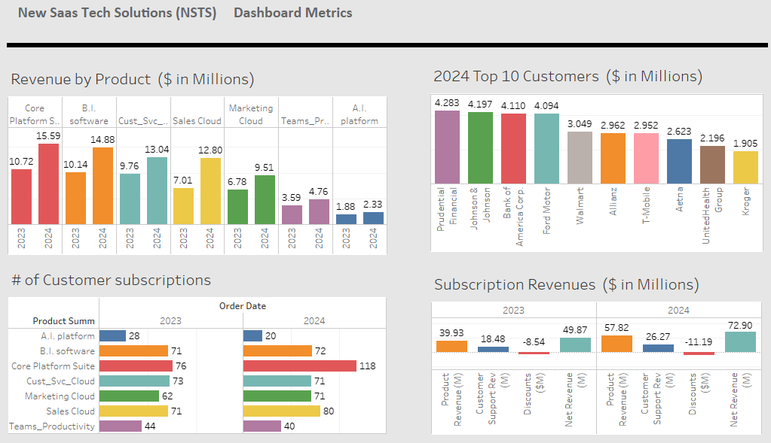

___________________________________________________

**Appendix Section:**

**Key Project and Analytics Challenges:** Based on Google internet searches of Kaggle.com and the Internet, no data was found that contains a complete set of realistic financial transactions for a Saas (Software-as-a-service) company.

A three-step solution was needed for this analysis project, as follows:

**First Step**: A basic dataset of online retail sales transaction data for Amazon.com was downloaded from Kaggle website. The data was then imported into an Excel file.

**Second Step:** Research was conducted on three major Saas companies in San Francisco Bay Area: Adobe, SalesForce.com, and Apple. The goal was to identify additional dimensions (data columns) that should be added to the dataset.

**Third Step**: Additional data was needed to meet these goals:

a) The data included detailed calculations of subscription fee revenue amounts by Product and by Customer Support Plan Level. Estimated number of User Licenses and Per-User License Fees for both the software subscriptions and the customer support plans were added to the dataset. The revenue calculations were then checked for reasonableness.

b) Additional dimensional attributes were added to the dataset so that if someone working in either Sales, Marketing, or Product departments asks for a report, we can easily pull the information by querying the dataset. Examples: Software product level (Standard vs. Premium), Customer support plan levels (Standard, Premier, and Signature), Product Name, Product Type, and Customer Industry and Segment. The data was organized inside Excel, SQL, and Tableau so that we can support revenue reporting by these dimensions.

c) The dataset included two full years of detailed revenue transactions to allow a comparison of year-over-year financial results on various dashboards and metrics reports.

**______________________________________________________**

**SQL Database Design Overview (Table relationships)**:

_______________________________________________________

**Next Steps:**

In the future, the following additional analysis projects could be performed:

1. An annual Sales Forecast vs. Target vs. Budget Analysis. Several meetings between the Finance, Sales and Marketing teams would be required to prepare such an analysis. During the meetings, discussions about various sales revenue growth assumptions could be used as inputs into a financial model. The financial model could provide the leadership team with accurate estimates of future subscription revenues over the next six to eighteen months.
2. Customer Segmentation (Cohort Analysis) Analysis. Behavioral analytics can be developed to help to improve customer experience and increase retention.
3. Recency, frequency, monetary value (RFM) Analysis. RFM analysis can be used by the marketing team to segment a company’s consumer base by their purchasing patterns or habits. The model evaluates customers’ *recency*(how long ago they made a purchase), *frequency*(how often they make purchases), and *monetary value* (how much money they spend).